HTTP1.1 vs HTTP2

What is HTTP?

HTTP (Hypertext Transfer Protocol) is underlying protocol developed by Tim Berners-Lee and his team between 1989-1991 for transferring files -- such as text, images, sound, video and other multimedia files -- over the web.

It is an [application layer](https://en.wikipedia.org/wiki/Application_layer) protocol designed within the framework of the [Internet protocol suite](https://en.wikipedia.org/wiki/Internet_protocol_suite).

How HTTP works?

HTTP protocol is based on a client-server model. Clients and servers communicate by exchanging individual messages. The messages sent by the client, usually a Web browser, are called requests and the messages sent by the server as an answer are called responses. The client submits an HTTP request message to the server. The server, which provides resources such as [HTML](https://en.wikipedia.org/wiki/HTML) files and other content or performs other functions on behalf of the client, returns a response message to the client. The response contains completion status information about the request and may also contain requested content in its message body.

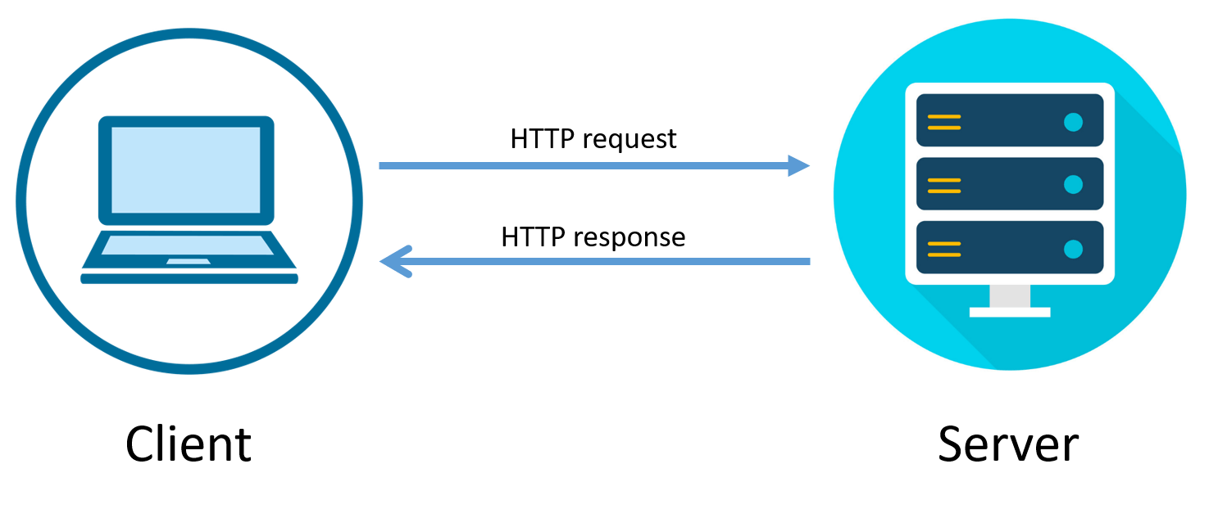

Evolution of HTTP

In 1989, while working at CERN, Tim Berners-Lee wrote a proposal to build a hypertext system over the internet.

Initially called the Mesh, it was later renamed the World Wide Web during its implementation in 1990. Built over the existing TCP and IP protocols, it consisted of 4 building blocks:

* A textual format to represent hypertext documents, the [Hypertext Markup Language](https://developer.mozilla.org/en-US/docs/Web/HTML) (HTML).
* A simple protocol to exchange these documents, the Hypertext Transfer Protocol (HTTP).
* A client to display (and edit) these documents, the first web browser called the Worldwide Web.
* A server to give access to the document, an early version of httpd.
* [HTTP/0.9 – The one-line protocol](https://developer.mozilla.org/en-US/docs/Web/HTTP/Basics_of_HTTP/Evolution_of_HTTP#http0.9_%E2%80%93_the_one-line_protocol)
* [HTTP/1.0 – Building extensibility](https://developer.mozilla.org/en-US/docs/Web/HTTP/Basics_of_HTTP/Evolution_of_HTTP#http1.0_%E2%80%93_building_extensibility)
* [HTTP/1.1 – The standardized protocol](https://developer.mozilla.org/en-US/docs/Web/HTTP/Basics_of_HTTP/Evolution_of_HTTP#http1.1_%E2%80%93_the_standardized_protocol)
* [HTTP/2 – A protocol for greater performance](https://developer.mozilla.org/en-US/docs/Web/HTTP/Basics_of_HTTP/Evolution_of_HTTP#http2_%E2%80%93_a_protocol_for_greater_performance)
* [HTTP/3 - HTTP over QUIC](https://developer.mozilla.org/en-US/docs/Web/HTTP/Basics_of_HTTP/Evolution_of_HTTP#http3_-_http_over_quic)

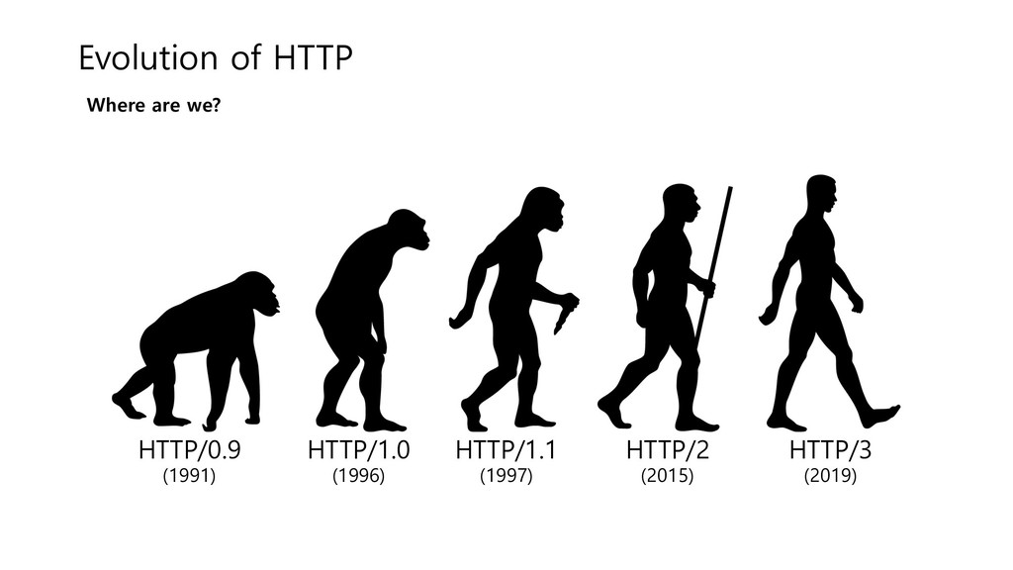

HTTP1.1 vs HTTP2

|  |  |  |
| --- | --- | --- |
|  | HTTP1.1 | HTTP2 |
| 1. | It’s a text protocol | It’s a binary protocol |
| 2. | It can be read and created manually. | It can't be read and created manually. |
| 3. | There is a head of line blocking that blocks all the requests until it doesn’t get all the resources | It's a multiplexed protocol. Parallel requests can be made over the same connection |
| 4. | It compresses data by itself. | It uses HPACK for data compression. |